UID LAB EXPERIMENT 8
Create storyboards to represent the user flow for a mobile app (e.g., food delivery app) using Balsamiq.
SAILOO S
230701277

1. Introduction
This document provides accurate screen designs based on the four new images provided, correcting previous inconsistencies. The flow covers: account creation → restaurant selection → payment → order tracking.
2. Corrected Screen Documentation
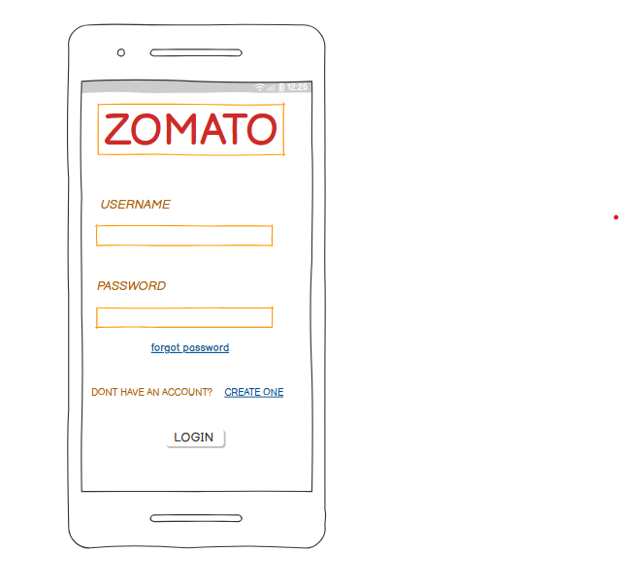
Screen 1: Account Creation
Purpose: User registration
Components:
"ZOMATO" logo (header)
Prompt: "DONT HAVE AN ACCOUNT? CREATE ONE"
Design Notes:
- Minimalist design with single call-to-action
- Missing input fields suggest this is a secondary screen

Screen 2: Restaurant Selection
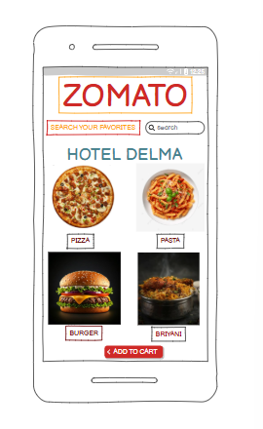
Purpose: Browse dining options
Components:
- Header: "ZOMATO" + search bar

- Featured venue: "HOTEL DELMA"

- Categories:
- "PIZZA"
- "PASTA"
- "BURGER"
- "BRIYANI"

- Design Notes:
- Search placeholder appears localized/informal
- Category names show creative spelling variations

Screen 3: Payment
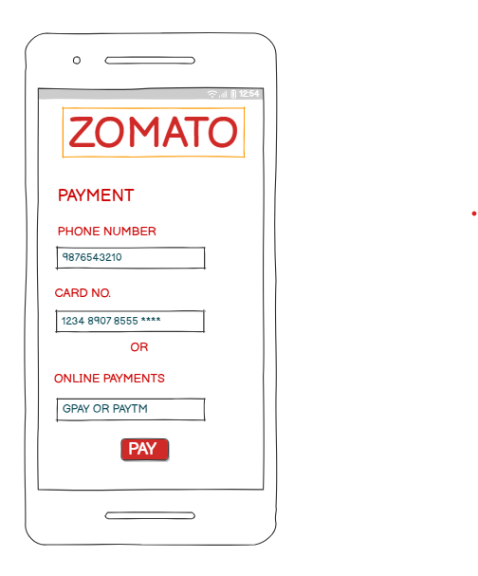
- Purpose: Secure transaction

- Components:
- Header: "PAYMENT"
- Fields:
- "PHONE NUMBER" (pre-filled: 9876543210)
- "CARD NO." (masked: 1234 8907 8555 ****)

Options:
"ONLINE PAYMENTS"
- "GPAY OR PAYTM"
Action: "PAY" button
Design Notes:
- Shows real masked card number format
Specific payment app references

Screen 4: Order Tracking
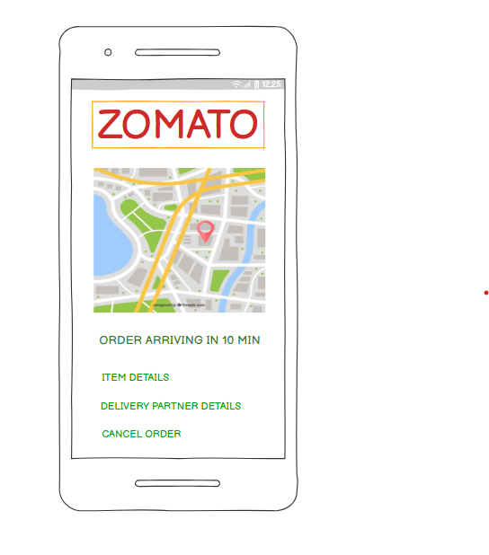
Purpose: Delivery status
Components:
Header: "ZOMATO"
Status: "ORDER ARRIVING IN 10 MIN"
Details:
- "ITEM DETAILS"
- "DELIVERY PARTNER DETAILS"
Action: "CANCEL ORDER" button
Design Notes:
- Clean status notification
- Two-tier detail structure

3. User Flow Correction
1. Account Creation → 2. Restaurant Selection → 3. Payment → 4. Order Tracking

4.Balsamiq Implementation Guide
1. Text Components:
- Used exact text from images
2. Search Bar:
- Added magnifying glass icon + placeholder text
3. Payment Card:
- Used "****" masking for card numbers
4. Status Screen:
- Added countdown timer visual near "10 MIN" text

